

Instructor: Dr. G.E. Antoniou

November 8, 2018

Day

Homework # AL1

Dos Santos Ferreira, Joao Paulo

CSIT 230_02 – Computer Systems

Department of CSIT

# Problem 1:

Write a MIPS Assembly program to ADD the 5 numbers: 1, 2, 3, 4, 5. (as in ex–1)

• Use only the instructions: [ add ] and [ li ]

**Source Code:**

.text

.globl main

# The following program adds the numbers 1, 2, 3, 4, 5

# using [li], [add] and different registers

main:

# loads the each value in a different register

li $t0, 1

li $t1, 2

li $t2, 3

li $t3, 4

li $t4, 5

# adds the values in the registers one at a time

add $t5, $t0, $t1

add $t5, $t5, $t2

add $t5, $t5, $t3

add $t5, $t5, $t4

#ends the program

li $v0, 10

syscall

**Result:**

# 

# Brief Comments:

The program runs correctly, according to the specifications. One register is used for each value, each value in the registers is added one by one and stored at $t5. The result of the sum of the five numbers is stored in the register $t5.

# Problem 2:

Write a MIPS Assembly program to ADD the 5 numbers: 1, 2, 3, 4, 5. (as in ex–1)

• Use only the instructions: [ addi ] and [ li ]

**Source Code:**

.text

.globl main

# The following program adds the numbers 1, 2, 3, 4, 5

# using [li], [addi] and different registers

main:

#loads the first value in a register

li $t0, 1

# adds imediately the remaining values one by one

# stores each value in a different register

addi $t1, $t0, 2

addi $t2, $t1, 3

addi $t3, $t2, 4

addi $t4, $t3, 5

#ends the program

li $v0, 10

syscall

**Result:**

# 

# Brief Comments:

The program runs correctly, according to the specifications. $t0 stores the first number, $t2 stores the sum of the first two numbers, $t2 stores the sum of the first three numbers, $t3 stores the sum of the first four numbers, $t4 stores the sum of all of the five numers.

# Problem 3:

Write a MIPS Assembly program to ADD the 5 numbers: 1, 2, 3, 4, 5. (as in ex–1)

• Use only the instructions: [ addi ] and [ li ] … and ONLY the register: [$t0]

**Source Code:**

.text

.globl main

# The following program adds the numbers 1, 2, 3, 4, 5

# using [li], [addi] and only the register [$t0]

main:

#loads the first value in a register

li $t0, 1

# adds imediately the remaining values one by one

# stores the result in the same register

addi $t0, $t0, 2

addi $t0, $t0, 3

addi $t0, $t0, 4

addi $t0, $t0, 5

#ends the program

li $v0, 10

syscall

**Result:**

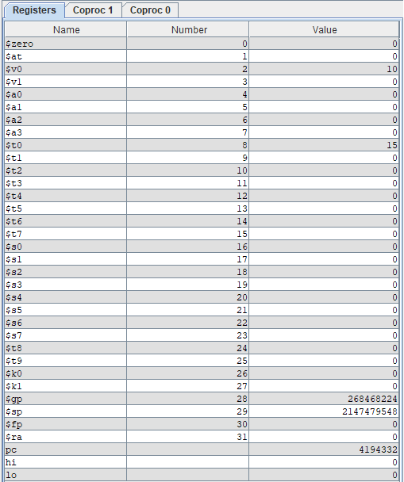

# Brief Comments:

The program runs correctly, according to the specifications. An initial value is loaded into register $t0, after that each number is added to the value at that register and the result replaces the initial number. At the end $t0 holds the sum of the five numbers.